**Know How To Test Car Battery Charge: Using Process of Car Battery Charger**

Basically, a car battery is a rechargeable battery used to launch motor vehicles. Its main function is to feed the motor with an electric current which activates an internal combustion engine with a chemical drive and power the motor. In other words, your automobile battery supplies the power required for electrical components. The electricity that drives your car and supplies voltage for its trigger also changes chemical energy. It also stabilizes the current-voltage of your motor. An example of a six-cell wet cell battery is an automobile battery. The alternation panels of a plumbing alloy grid filled with sponge plates or covered by plaster dioxide are included in every pitched cell. Every cell has a sulfuric acid solution packed with electrolytes.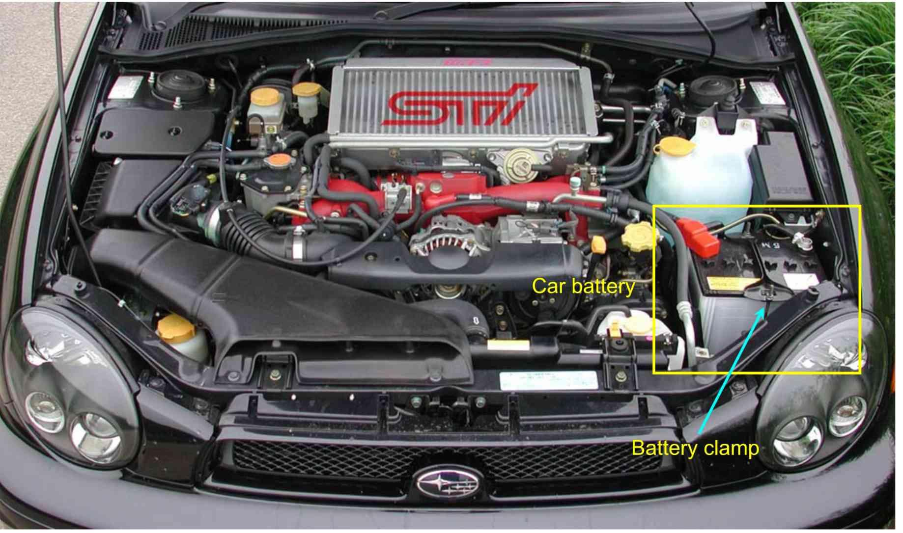

**Car Battery Charge**

An ordinary battery with a capacity of about 48 amp-hours can produce 1 Amp for 48 hours when completely charged, 2 Amps for 24 hours, 8 Amps for 6 hours, etc. The sooner a flat battery is recharged, the higher is the charge output. It will take roughly 10-24 hours to completely charge a standard battery with a common charging amplifier of 4-8 amperes. It would take around 2-4 hours to boost your battery to start the motor. A 12-volt battery is the basic car battery in today's automobiles. Every battery contains 6 cells with a full charge of 2.1 volts. Fully charged 12.6 volts or greater is termed automobile batteries.

Your alternator charges your automobile battery. In general, your alternator will charge your battery faster if you can maintain your engine rpm higher. You should be able to charge your automobile battery within 30 minutes when traveling on a freeway. It might take an hour or more if you drive in town. In principle, 80 amps can be obtained from your alternative while you are idle. In around 2 hours, you can charge a flat battery to 80 percent full, provided you have an alternator that can provide roughly 14 volts all the time at the battery terminals. Car batteries are always charged without disconnection. For a standard battery starter: connect the positive clamp into the positive battery terminal and switch on the charger at a grounded location on the chassis. Although the usage of a good-grade charger is not likely to overload, the battery should not be attached to the charger for longer than 24 hours.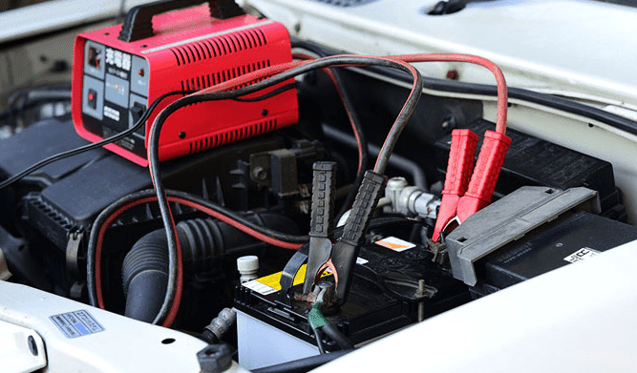

By charging overnight, a whole charge is frequently attained. Some chargers allow for at least partial repair of the battery even after deeper discharge. There is an indicator for your battery condition. The lowest point is 9.5 volts. Replace the battery if the voltage drops below.

**How to Test Your Car Battery Voltage?**

Many car users carry a doubt in their minds about which steps they should follow while testing their car’s battery voltage. Here are some important tips for them-

1. Make sure your vehicle is turned off before testing.
2. Remove the positive device lid of the battery.
3. Check the voltmeter for the reading.
4. Every voltage above 12.9 volts is a positive sign of good voltage for your battery. You don’t need to worry in that case.
5. Charge your battery if the voltmeter displays a voltage of anything below 12.4.

**Car Battery Charger**

Every single material in this world needs the energy to survive or run. The human body needs food items, while machines need electricity or charge. To start a car engine, a spark is needed which is produced by the car battery. Car battery chargers restore energy to a car battery through electrical current. They plug into a wall outlet, drawing AC current and converting it to the 12-volt DC current battery stores.

It might take at least 4 hours to recharge a dead automobile battery and up to 24 hours depending on the charge and battery size. Usually, battery chargers are placed at four amps, although the chargers are stronger. Fully charged car batteries provide at or above 12.6 volts measurement. The reading needs to be between 13.7 and 14.7 volts when the engine is operating. You may test your electrical system by starting the car and turning on the headlamps if you don't have a multimeter to inform you about your battery tension.

Usually, a fully loaded battery shows a voltmeter of 12.6 to 12.8 volts. If you find any voltage between 12.4 and 12.8 on your voltmeter, your battery is in good form. Any voltage that exceeds 12.9 volts is a strong sign of the excess voltage of your battery. Remove the (black) terminal first when you detach a car battery, then the positive terminal (red). Thankfully, many current vehicle battery chargers offer an efficient repair, not only restoring the full power of your battery but also providing your car with an emergency start capability.



Although the usage of a good-grade charger is not likely to overload, the battery should not be attached to the charger for longer than 24 hours. By charging overnight, a whole charge is frequently attained. Some chargers allow for at least partial repair of the battery even after deeper discharge. You can charge a dead battery, and a dead battery, whether locked in your garage and handling yourself or in the midst of none of you, is usually a straightforward remedy, depending on the circumstances you're in. You need competent, quick, and efficient service at a glance.

**Instructions to Use The Battery Charger**

* First of all, make sure the charger is disabled.
* Add the positive cable of the charger to the positive battery terminal.
* Connect the negative cable to the negative battery connector on the charger.
* Set the loader to the slowest rate of charging.

**Overcharging Issues**

The sulfuric acid and distilled water combination are boiled by an overloaded battery. The battery housing might start to melt or swell heat to the touch. Into the sealed battery cells, flammable hydrogen can build up, causing the box to inflate and filter through tiny ventilations.

**Undercharging Issues**

The battery will progressively produce sulphurization if it does not receive enough charge to return the battery to full charge. This error can be caused if the automobile is utilized for short trips or stop-start urban driving just from time to time.